USB Camera

客户名称Customer Name：/

型 号Model：003-0511/0447

日 期Date：2021-8-15
确认回签Approved：

内 容 CONTENT
- 目的 Purpose
- 效力 Effect
- 技术参数 Technical parameters
- 外观尺寸 Shape and Dimensions
- 镜头结构 Lens Construction
- 功能检验标准 Function inspection criteria
- 外观检验标准 Visual inspection criteria
- 可靠性测试 Reliability Test
- 包装要求 Packaging requirements
- 其他 Other
版本Version | 编写Compile | 审核Auditing | 批准Authorize
V1.0 | 陈宝辉 | 陈宝辉 | 朱中文

一、目的（Purpose）
为了全面地描述技术合作中所指的技术规格，通常需要由一整套文件予以表示。作为其中的一部分，本技术规格规定了双目摄像头模组应达到的特定技术规格，对于该型号货品具有约束力。
For a comprehensive description of technical cooperation referred to the technical specifications, usually a set of documents required by the express. As one part of the technical specifications of the Binocular camera modules should meet the specific technical specifications for the goods model binding.

二、效力（Efficacity）
如果本规范与该类货品的通用技术规格书中的规格不一致时，以本规格书中的规定为准。
If the norms of such goods with a common technical specifications of the specification book is inconsistent to the specifications book shall prevail.

三、技术参数（Technical parameters）
项目（Items） | 参数 （Parameters）
感光片（SENSOR） | RXS2719 | AR0230
感光片尺寸（Lens Size） | 1/2.7” | 1/2.7”
最高有效像素（Most effective pixels） | 1920*1080 | 1920*1080
数据格式 (Data Format) | YUY/MJPG | YUY/MJPG
像素大小 (Pixel Size) | 3*3μm | 3*3μm
宽动态范围（dynamic range） | 76DB | 96DB
镜头（Lens） | 视角FOV ：D= 95
 | 光学总长Optical length ：15.29MM
 | 结构 lens construction：2G2P
 | 接口mount ：M12*P0.5mm
对焦focusing | 定焦(Fixed focus)
帧 速 (Frame rate) | 30fps
自动控制 (auto control) | 饱和度(Saturation)，对比度(Contrast)，锐度(acutance)，白平衡 (White balance)，曝光（exposure）。
红外灯(IR) | 850nm 60°
供电电压（Voltage） | DC 5V
最大工作电流 (working current) | MAX 500mA
USB接口（USB Connector） | USB2.0
储存温度 (Storage Temperature) | -20C to +70C
其他(other) | 双SENSOR 黑白+彩色
兼容系统  (system compatibility) | 1、Windows XP（SP2,SP3）、Vista 、7、8、10
 | 2、Linux or OS with UVC driver

四：尺寸外观Appearance Dimension
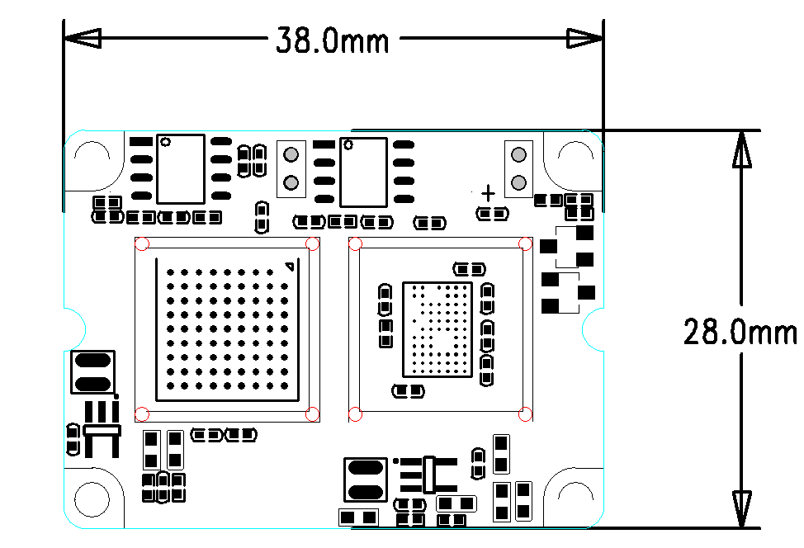

五：镜头参数Lens Specifications
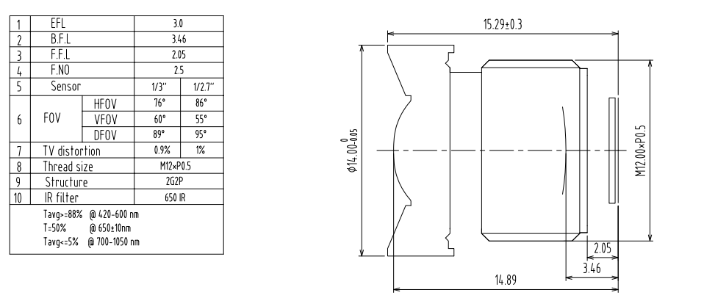

六、功能检验标准 （Function inspection criteria）
（一）功能定义:
1.摄像头模组电气性能、图像质量。(Electrical properties , the quality of image. )
- 检验方法:( Inspection methods)
1. 人员: 外观检查人员需经过培训并且辨色能力正常,其视力应达到1.0以上(矫正后达到1.0以上亦可),辨色能力应可通过标准测试。
Staff: The appearance of the inspectors to be trained and the capacity of normal color vision, Its vision to achieve more than 1.0 (after correction can also be reached more than 1.0), Color vision capability should be available through standard tests.
2. 工具：连接电脑，用Amcap 测试软件检测图像。
Tool: Connect the computer, Testing images with Amcap software.
3. 距离和时间: 观察距离为30 ∼ 55cm,观察时间为每个面3 ∼ 5秒。
Distance and Time: Observation distance: 30 ∼ 55cm,
Observation time for each surface: 3 ∼ 5seconds
4. 检验环境: 外观检验应在不刺目的荧光灯下检查,其最低照度应在100尺烛光亮度以上，或者是60W日光灯，1.5m距离下检验。
Test condition: Visual inspection should be conducted under anti-glare fluorescent lamp with min 100 feet candela luminace, or under 60 watt fluorescent lamp of 1.5m distance.

- 接受标准 (Accept criteria)
      - 图像无花屏、彩屏、变色。(The image has no mess, color screen and discoloration.)
      - 无白点、黑点、脏污、暗角。(There is no white spot, black spot, dirt or dark angle in the image.)
      - 图像清晰，四周清晰度一至。(TThe image is same clear on all cornors)

七、外观检验标准 （Visual inspection criteria）
- 外观表面定义:( The appearance of the definition)
  - 摄像头模组的外观 (Camera module appearance)
- 检验方法:( Test methods)
  - 人员: 外观检查人员需经过培训并且辨色能力正常,其视力应达到1.0以上(矫正后达到1.0以上亦可),辨色能力应可通过标准测试。
Staff: The appearance of the inspectors to be trained and the capacity of normal color vision, Its vision to achieve more than 1.0 (after correction can also be reached more than 1.0), Color vision capability should be available through standard tests.
  - 距离和时间: 观察距离为50 ∼ 75cm,观察时间为每个表面3 ∼ 5秒。
Distance and Time: Observation distance: 50 ∼ 75cm,
Observation time for each surface: 3 ∼ 5seconds
3. 检验环境: 外观检验应在不刺目的荧光灯下检查,其最低照度应在100尺烛光亮度以上，或者是60W日光灯，1.5m距离下检验。
Test condition: Visual inspection should be conducted under anti-glare fluorescent lamp with min 100 feet candela luminace, or under 60 watt fluorescent lamp of 1.5m distance.
4.观察角度: 观察角度在40° ∼ 50°之间。
Observation angle: Observation angle between 40° ∼ 50°.

- 接受标准 (Accept criteria)
  - 清洁程度：部件必须无污点、无尘、无油脂及无其它污迹。由于运输材料造成的污迹如果能够吹去或抹去则是可以接受的。
The degree of Cleanliness : Components must not stain, clean, no grease and other stains. Because of s s stains caused by the transport of materials can erased ， it is acceptable.
  - 装配表面：需装配的零部件应避免有划痕、凿痕、凹痕、弯折、破裂、压痕、擦伤或其它因不当装配所引起的缺陷。
Assembly surface: Assembly of parts and components required to have scratches should be avoided, dent, bend, break down, Indentation, scratches or other improper assembly defects.

八、 可靠性测试 (Reliability Test)

项目Items | 条件Condition | 规格Specification
高温实验  High Temperature Test | 温度(Temp)：80℃  时间(Time)：96H | 无异常No abnormal
低温实验  Low Temperature Test | 温度(Temp)：-20℃  时间(Time)：96H | 无异常No abnormal
湿度实验  Humidity Test | 温度(Temp)：60℃  湿度(Humidity)：80-85％  时间(Time)：24H | 无异常No abnormal
镜头座拉力实验  Cable Tensile Strength Test | 荷重：4KG  持续时间：60秒 | 无异常No abnormal
跌落测试（单体）  Drop Test | 高(High)：60CM  回数：10次  木板上 | 电性能正常  Electric normal
跌落测试（整箱）  Drop Test | 高(High)：60CM  一角三边六面  木板上 | 电性能正常  Electric normal
震动测试（单体）  Vibration Test | 1.震动机的震动频率调至50Hz；  Vibration machine vibration frequency to 50Hz  2.震动幅度Vibration amplitude 1.5MM；  3.震动时间Vibration time 30 Minutes | 电性能正常  Electric normal
拔插实验  USB connector | 回数：2500回 | 电性能正常  Electric normal

九.包装要求(Packing Request)
1、产品应严格根据产品特点制定相应的包装标准并遵照执行，以保证产品规定使用和储存期内，达到防静电、防湿、防震、防霉、防野蛮装卸等标志及相关保质要求。
Products should be strictly in accordance with the characteristics of the development of the corresponding Product packaging standards and in compliance with the implementation, guarantee the use and storage of products during the period, reaching anti-static, moisture, shock-proof, mildew, anti-barbaric handling related signs and shelf-life requirements.
2、产品外包装上应标明：供方名称/标志、产品型号规格、内装数量、生产日期/批号和定单号。
Product packaging should be marked: Supply-side name / logo, Product Model specifications, containing the number, production date / batch number and order number.
3、包装及装箱方案依据客户要求，由双方协商具体细节，以封样为准。
Packaging and packing programs based on customer requirements, specific details of consultations by both parties, to finished products as the standard.

十.其它(Others)
1.本承认书的更改需经双方确认，任何一方单独修改无效。
The recognition of the need to change the book recognized by both parties, either party to amend a separate as null and void.
2.本承认书在客户收到的七个工作日内，必须签章返回，逾期视为默认。
Admit in the book the customer received within seven working days, must return signature, late regarded as the default.

